**Exemplar: Creating an executive data summary**

**Overview**

In the exercise *Creating an Executive Data Summary*,you were asked to put into practice a range of formatting and calculation techniques that you have learned over the past couple of weeks.

Your task in this exercise was to create an executive summary of a business’s month-by-month profit margin performance for Quarter 1 compared to the same period in the previous year.

You were required to make formatting changes that would make the worksheet easier to read and ensure the requested analysis results stand out. In addition, you were asked to create formulas that had to:

* Produce customized quarter-one monthly totals across two business years using the **SUMIF** function.
* Calculate the percentage difference for each month in quarter 1, 2023, from the same period in 2022.
* And use a logical function to test the order value and display the correct tax amount.

This reading provides you with a step-by-step guide for identifying these results. It also includes screenshots that you can compare against your work.

You can review the techniques required for this exercise in the following videos and readings:

* Video: [*Entering and formatting data*](https://www.coursera.org/learn/preparing-data-for-analysis-with-microsoft-excel/lecture/VKjca/entering-and-formatting-data)
* Reading: [*Working with rows and columns*](https://www.coursera.org/learn/preparing-data-for-analysis-with-microsoft-excel/supplement/9D9zp/working-with-rows-and-columns)
* Reading: [*Working with worksheets*](https://www.coursera.org/learn/preparing-data-for-analysis-with-microsoft-excel/supplement/9w9Lx/working-with-worksheets)
* Video: [*Sorting and filtering data in Excel*](https://www.coursera.org/learn/preparing-data-for-analysis-with-microsoft-excel/lecture/xn2kr/sorting-and-filtering-data-in-excel)
* Video: [*What is a formula?*](https://www.coursera.org/learn/preparing-data-for-analysis-with-microsoft-excel/lecture/GCuEI/what-is-a-formula)
* Video: [*Controlling calculations in action*](https://www.coursera.org/learn/preparing-data-for-analysis-with-microsoft-excel/lecture/QJeL7/controlling-calculations-in-action)
* Reading: [*Useful percentage calculations*](https://www.coursera.org/learn/preparing-data-for-analysis-with-microsoft-excel/supplement/xQVQl/useful-percentage-calculations)
* Reading: [*Functions that can be used to standardize text data*](https://www.coursera.org/learn/preparing-data-for-analysis-with-microsoft-excel/supplement/vltix/functions-which-can-be-used-to-standardize-text-data)
* Reading: [*Other Useful date calculations*](https://www.coursera.org/learn/preparing-data-for-analysis-with-microsoft-excel/supplement/Wd30P/other-useful-date-calculations)
* Video: [*Using the IF function*](https://www.coursera.org/learn/preparing-data-for-analysis-with-microsoft-excel/lecture/RS5PX/using-the-if-function)
* Reading: [*IF functions*](https://www.coursera.org/learn/preparing-data-for-analysis-with-microsoft-excel/supplement/cckTv/if-functions)

**Step 1: Download the File**

1. You downloaded and opened the *Microsoft Excel workbook Quarter One Report.xlsx.* The workbook contains only one worksheet called **Summary.**

The sheet contained sales information for specific products spread over two years. It included wholesale and retail prices for each product and the numbers sold. You had to reformat information so that the worksheet showed only the required data and displayed it effectively.

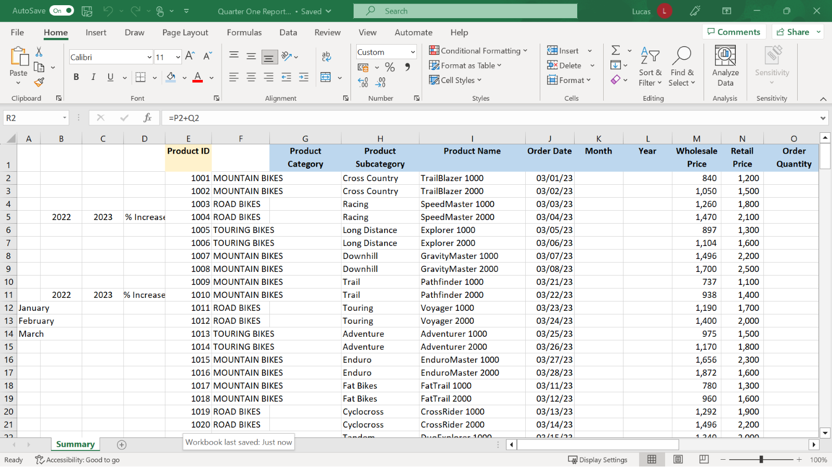

**Step 2: Add and format headings.**

1. The first task was to widen column **A** as it was not wide enough to display the month names in cells **A12** to **A14** correctly. By dragging or double-clicking the vertical line between the initial letters identifying columns **A** and **B**, it was possible to resize the column.

You then added a new blank column to the left of column **E**. Column **E** was titled **Product ID**. When inserting columns, it is important to remember that the new column is added to the left of the cursor position. You highlighted column **E** and then chose **Insert column** from the cells group on the **Home** ribbon or the right-click shortcut menu.

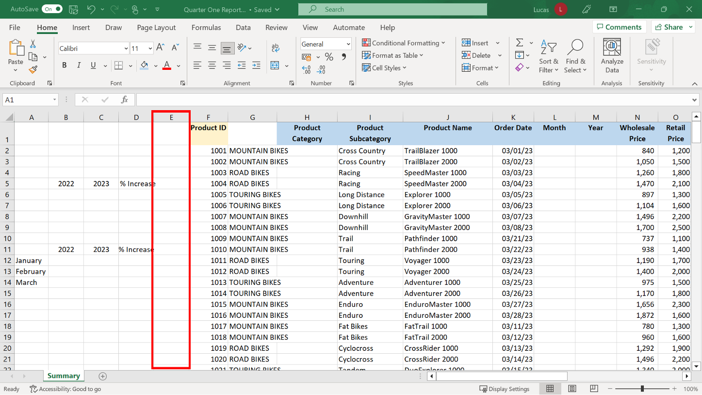

1. Next, you selected cell **A4** and typed the heading **TOTAL Q1 SALES.** Then you selected cell **A10** and typed the heading **Q1 MONTHLY TOTALS.**

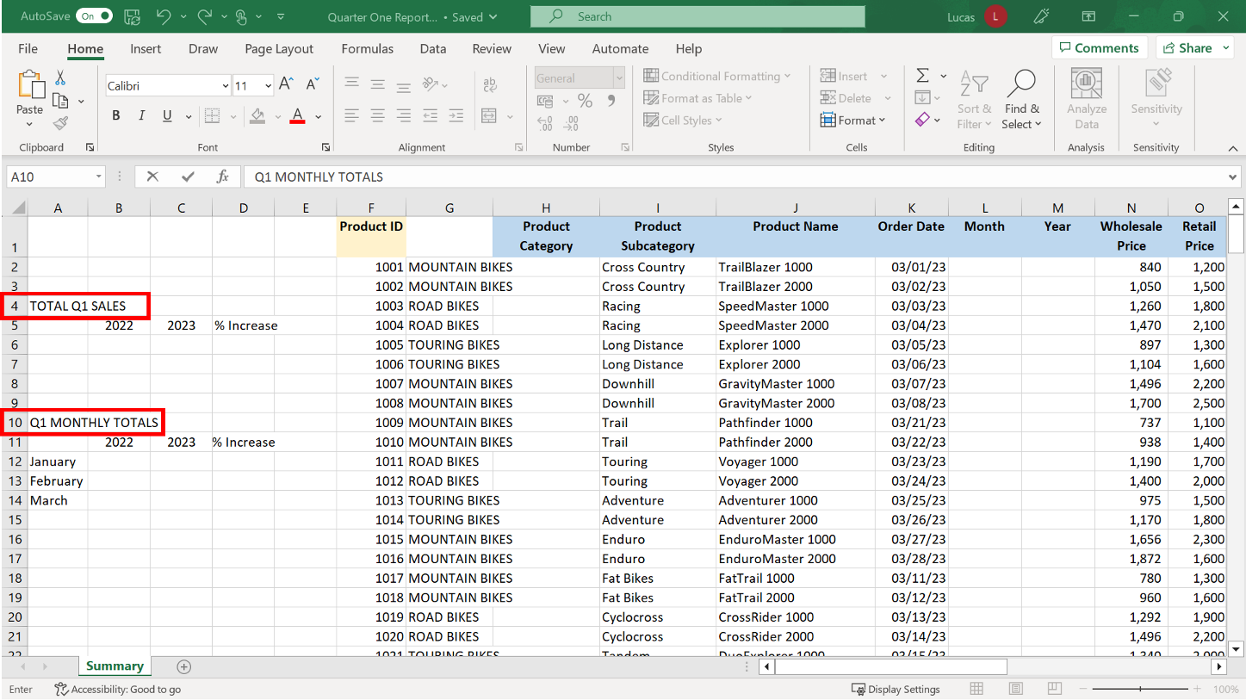

1. When the heading had been added to **A4** and **A10** you applied a range of formatting choices to ensure that the headings had impact. The quickest approach was to apply the formatting manually to cell **A4** and then use the **Format painter** feature to copy the same look to cell **A10**.

With the heading in **A4** selected, you used the **Font and Size** dropdown choices to adjust the appearance and size of the text. In the same **Font** section, you selected the **Bold** option to bold the text. Then you used the **Fill color** choice to change the background color of the cell.

The **Merge & Center** choice is in the **Alignment** section. This option helps to make headings appear professional by centering them above the table of information they relate to.

You began by typing headings in the cell at the left edge of the area that the heading had to be centered in. Then you highlighted from cell **A4** to the right edge. You selected the **Merge & center** button to merge the selected cells into one cell and display the heading in the center.

The **Format painter** feature is a useful tool to copy formats from one cell to another quickly. It copies the font, color, and **Merge & center** settings.

You positioned the cursor on cell **A4**, which was the cell that had the formatting you wished to copy. Then you selected the **Format painter** button. When the mouse pointer assumed a paintbrush shape, you selected cell **A10** to copy the formatting.

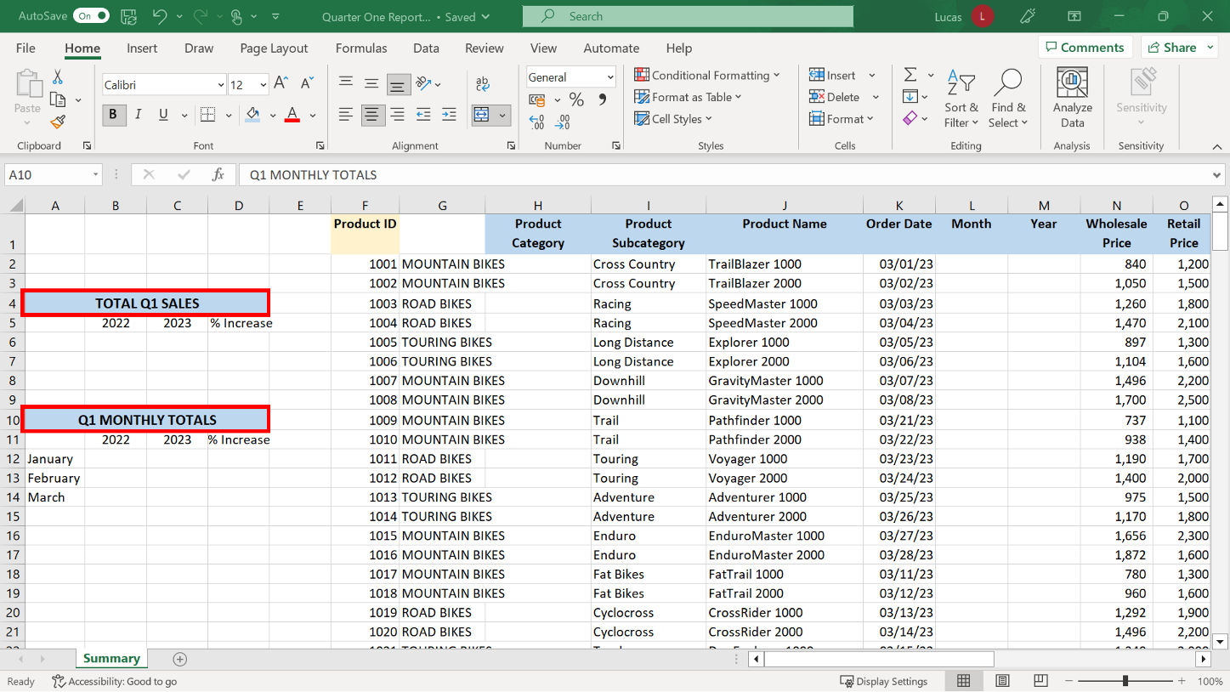

1. The headings in **B5**, **C5** and **D5** also needed to stand out from other content. You selected these cells and then applied **Bold** formatting and selected the **Wrap Text** choice to position the headings correctly in the cells. You then used the **Format painter** to apply the same formatting to **B11**, **C11** and **D11**.

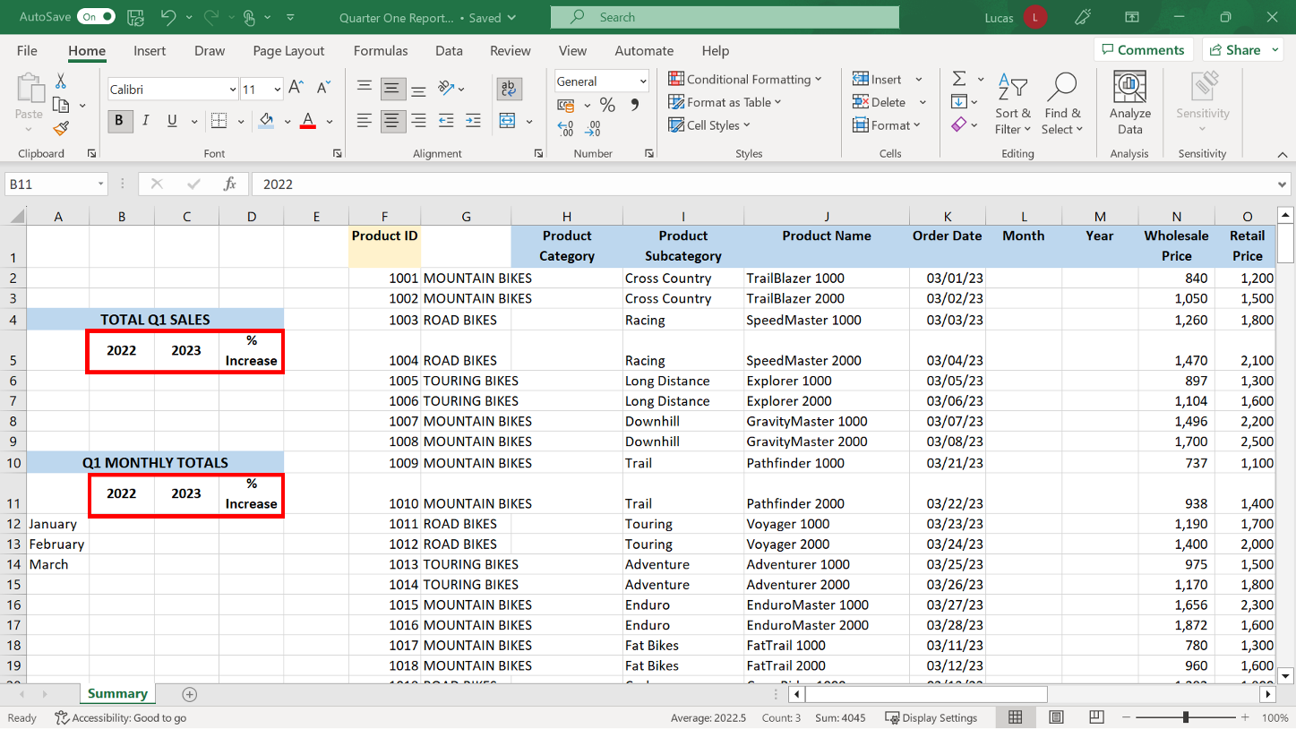

**Step 3: Customize and reorganize how the data is displayed.**

1. The entries in column **G** were in block capitals but you were asked to change the case. In cell **H2**, you created a formula using the **PROPER** function to copy the product name in cell **G2** The **PROPER** function is one of a collection of functions that can be used to change the case of text. It will format text as lowercase with a capital at the beginning of each word. In this worksheet, the correct syntax for this formula is:

**=PROPER(G2)** When this formula was applied, the result in cell **H2** was Mountain Bikes.

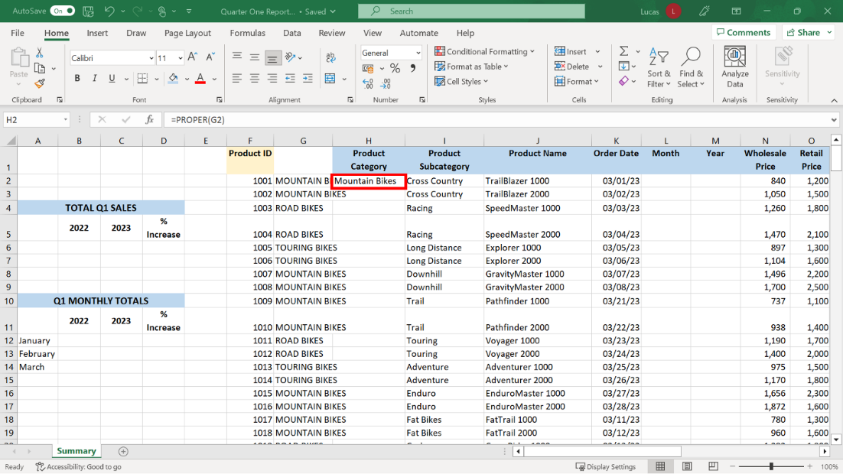

This formula had to be copied down column H using the **Autofill** feature. You first positioned the cursor on cell **H2**. There was a block of data to the left in column **G**, so you could use the double-click shortcut on the bottom right corner of the cursor to use the **Autofill** shortcut to copy the formula down column **H**.  Once the formula was copied down column **H** and had generated results, the formulas were no longer necessary. You selected the block of results, chose **Copy** on the **Clipboard** section of the **Home** ribbon, and then selected **Paste Values** from the dropdown on the **Paste** button. These options would also have been available on the right-click shortcut menu. Once the formulas had been removed, you deleted column **G** by selecting the column and then choosing the **Delete** option from the cells section of the **Home** ribbon or from the shortcut right-click menu.

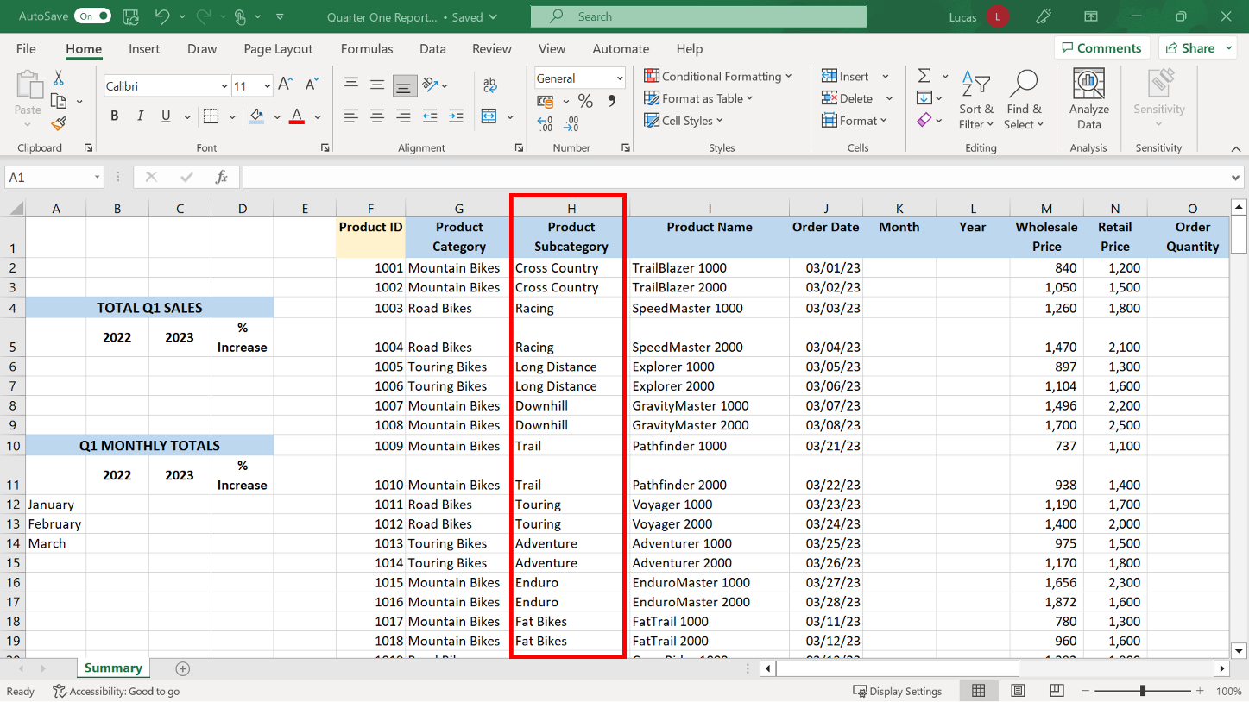

1. The block of sales data had to be sorted so that the row order would be suitable for the monthly total calculations required in a later step. The block had to be sorted by date oldest to newest without sorting the data in columns **A** to **D**. The presence of a blank column, column **E**, would normally prevent this from happening if the data is sorted using the **Quick sort** shortcut choices in the **Data** ribbon. However, you ensured that Excel would sort the correct content by highlighting the data before sorting it. If you were using a standard keyboard, you could have positioned the cursor on cell **F2** and then used the **Ctrl+Shift+End key** combination to highlight the correct block of data quickly. You selected the **Sort** choice on the **Data** ribbon because the data was already highlighted. The **Sort** dialog should automatically have been aware that row one contained headings. In the **Sort By drop-down,** you selected **Order Date**, and in the **Order drop-down**, **Oldest to Newest.**

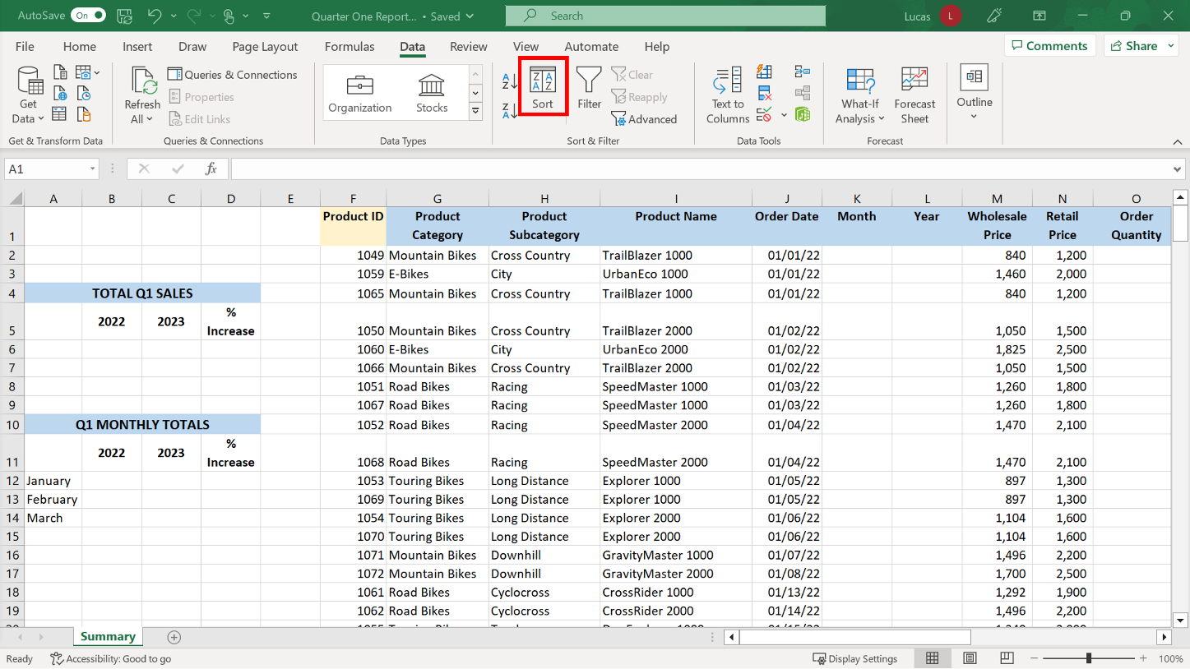

1. Some of the data was not relevant for the summary required so you highlighted column **F** and selected the **Hide and Unhide** choice on the **Format** dropdown in the **Font** section of the **Home** ribbon. Alternatively, you may have used the right-click shortcut menu to hide the column quickly. You repeated this process for columns **S** to **Y.** If there is data in a worksheet that does not need to be displayed, then hiding columns removes the content from view without deleting it. It is important that you remember that this is not a security measure, as the columns can easily be unhidden. However, it is a useful technique when screens are shared in presentations or meetings.

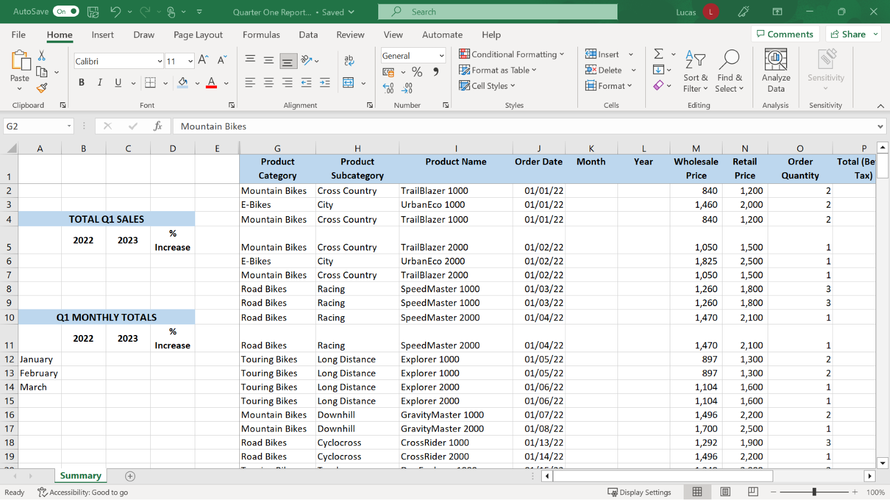

1. To make reading the data a smoother process, you were asked to freeze both rows and columns on the screen. You positioned the cursor on cell **G2** and selected the **View** tab to display the ribbon. You opened the **Freeze** dropdown and selected the **Freeze Panes** option. Columns **A** to **E** and row **1** which were above and to the left of the cursor, were now stay frozen on the screen.  Remember that, with **Freeze Panes,** the position of the cursor is used to determine the areas of the screen that should remain static.

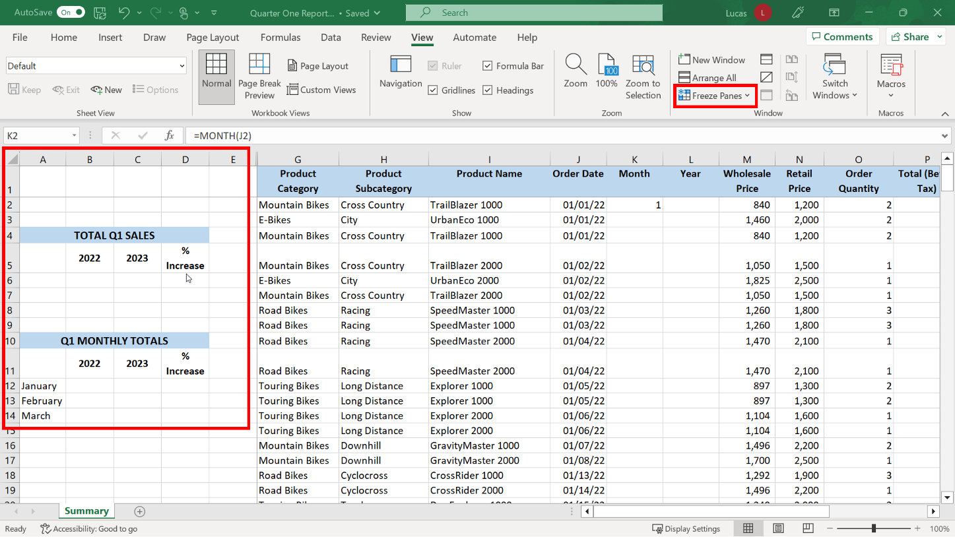

**Step 4: Use formulas to create new row information.**

1. You were asked to create a formula in **K2** using **MONTH** and a formula in **L2** using **YEAR** to extract the two component parts of the date in **J2**. These formulas also needed to be copied down as far as row **246**. The **MONTH** and **YEAR** functions are in the **Date and Time** category of functions. It will extract the stated element from the cell entry in **J2**, which is formatted as a date.  The syntax for the formula in **K2** was: **=MONTH(J2)** The result should be 1.

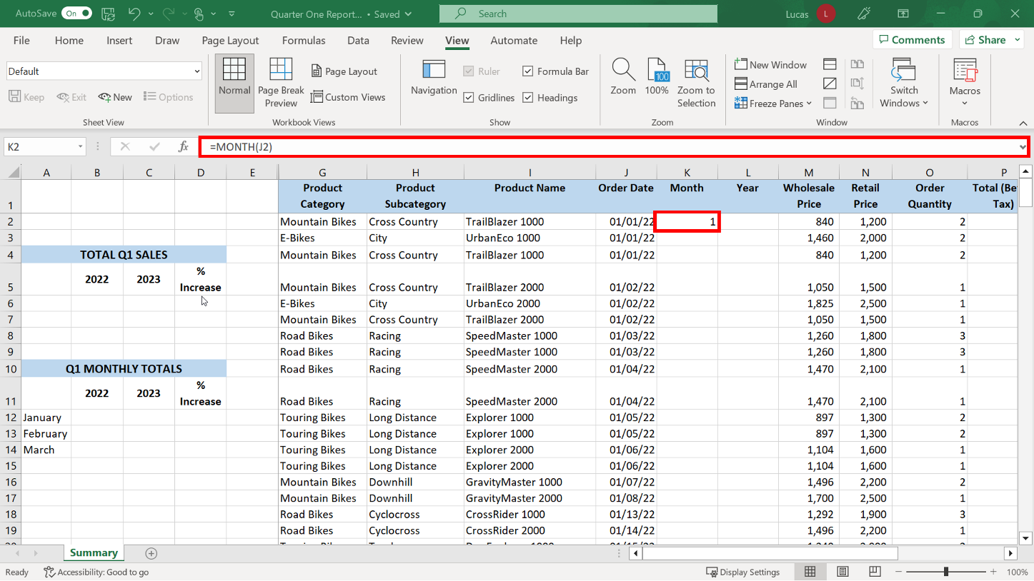

The syntax for the formula in **L2** should be:

**=YEAR(J2)**

The result should read 2022.

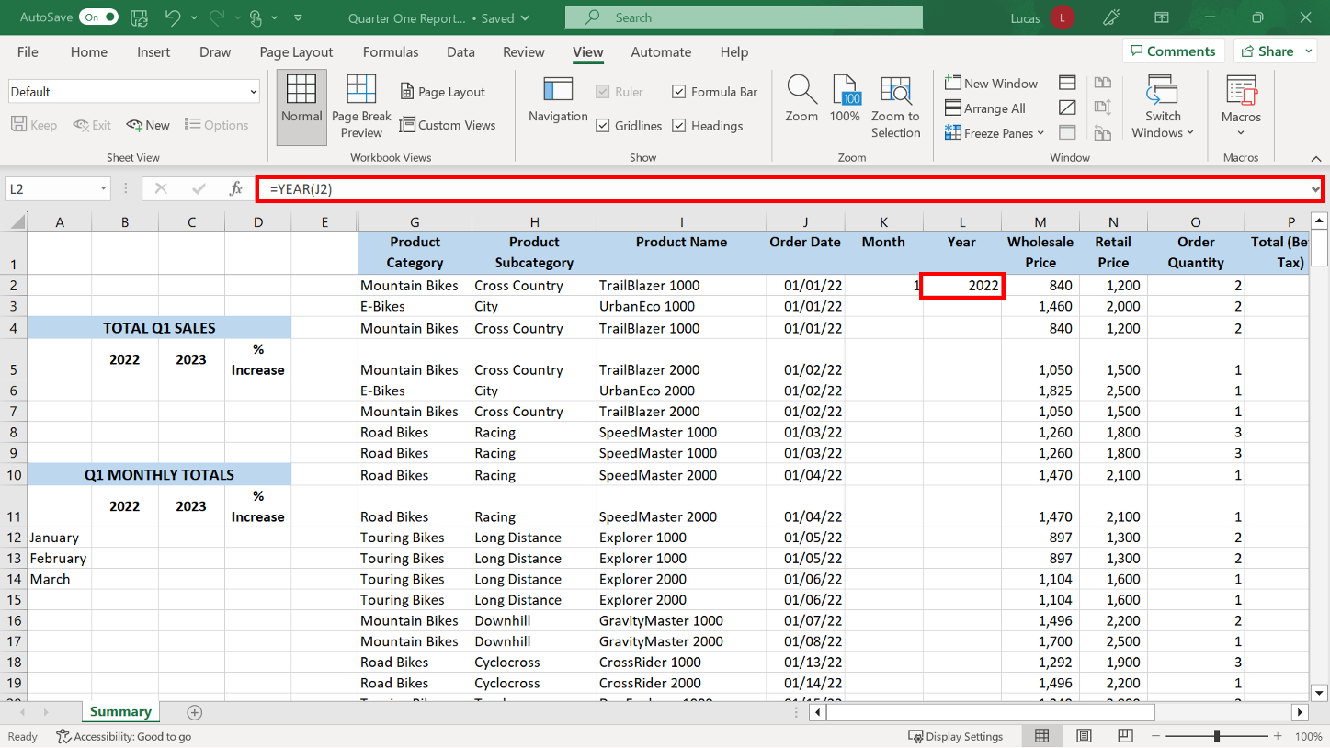

You then copied down the two formulas using the **Autofill** double-click shortcut or **Copy and paste.**

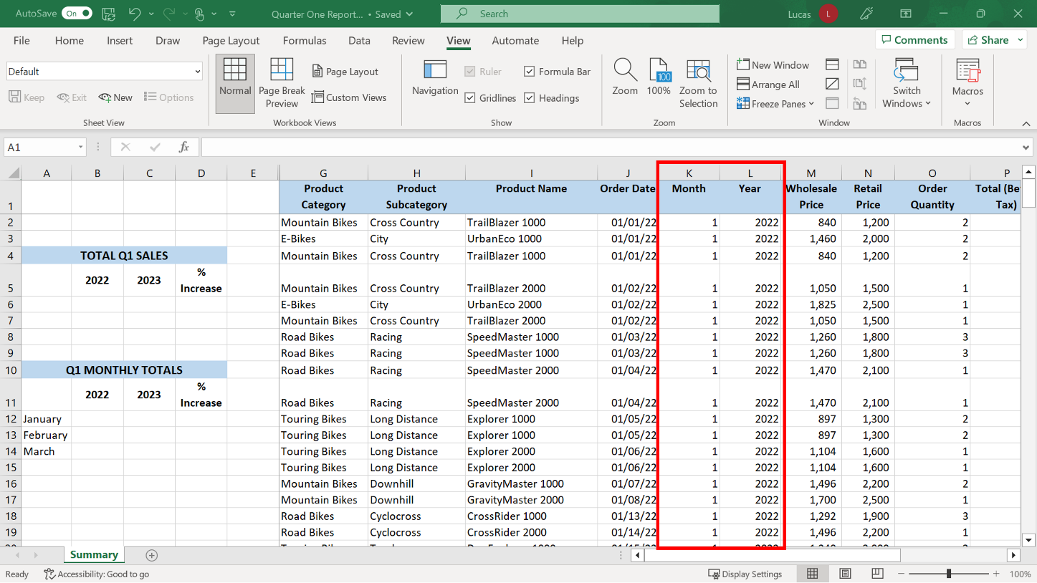

1. In **P2**, you created a standard multiplication formula that multiplied the retail price by the order quantity. You then copied the formula using **Autofill** or **Copy and paste**. The formula in **P2** should read: **=N2*O2** The result should be 2,400.

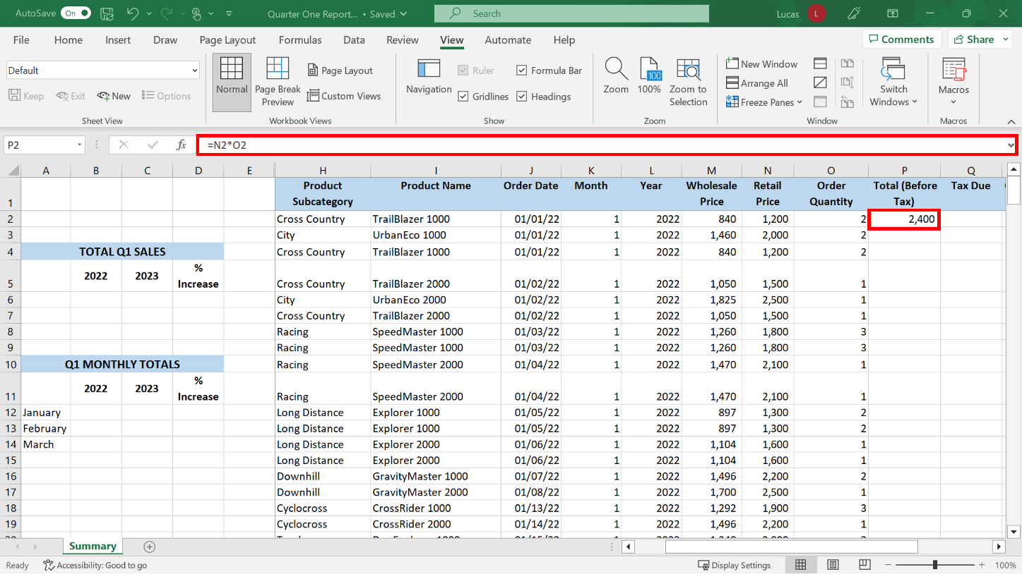

1. In cell **Q2**, you created a formula using an **IF** function that calculated if tax was due on the amount in **P2**. The **IF** function had to check if the amount in **P2** was over 2000. If it was, then the amount in **P2** had to be multiplied by 5%. If it was not, then cell **Q2** should display a 0. The **IF** formula in **P2** should read: **=IF(P2>2000,P2*5%,0)** Here the Value if true action is a formula embedded in the larger logical formula. The percentage calculation is processed because the logical test for the **IF** returns a value of TRUE. It is possible to have calculations as both the Value if true and the Value if false actions.  The result of this formula should be 120 which is 5% of the value in **P2**.

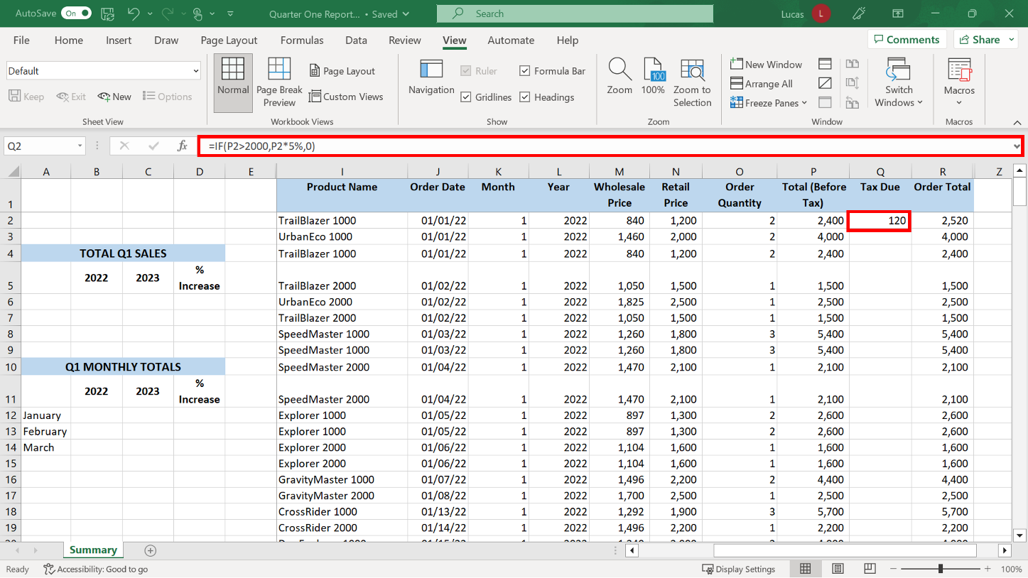

**Step 5: Create formulas to calculate and compare the profit margin across two years.**

1. In cell **B6**, you created a **SUMIF** formula to sum the sales values for 2022. The sales values were in the range **R2** to **R246**. The criteria range was the range **L2** to **L246**. You then created a similar formula in cell **C6** with the same cell ranges but changed the criteria to 2023. The formula in **B6** should read: **=SUMIF(L2:L246,2022,R2:R246)** The result in **B6** should be $330,500.

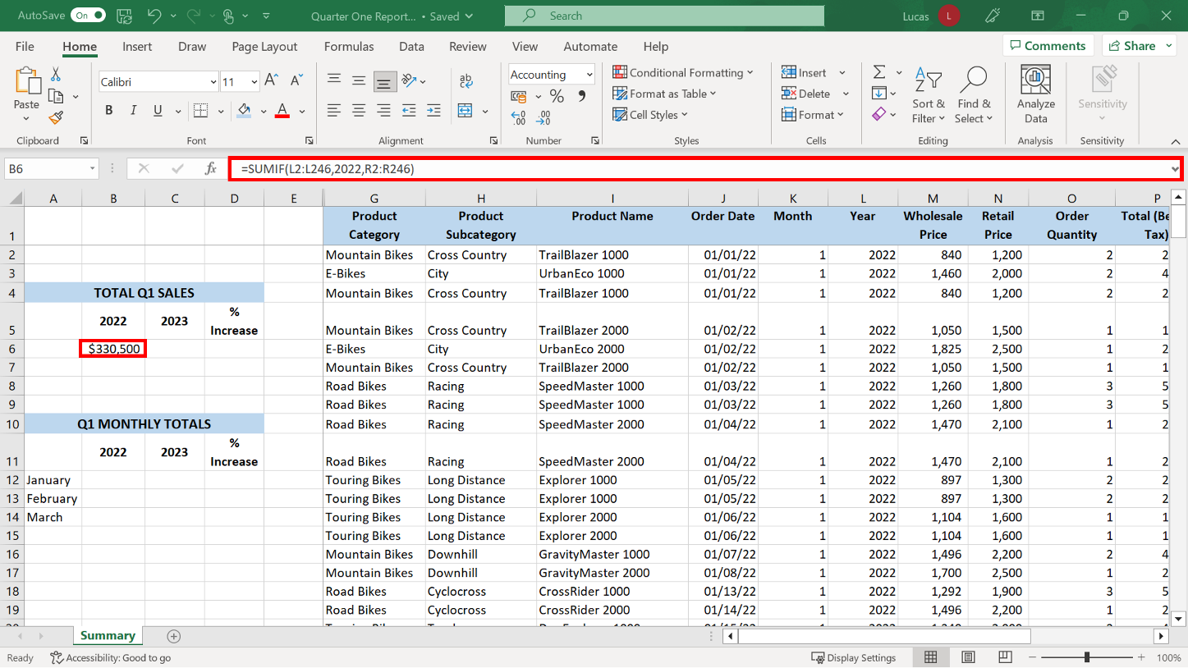

The formula in **C6** should read:

**=SUMIF(L2:L246,2023,R2:R246)**

The result should be $453,830.

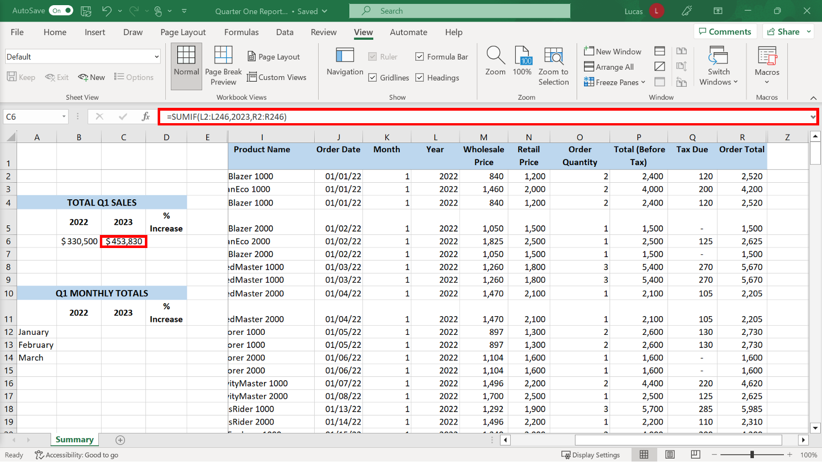

1. In cell **B12** you created a **SUMIF** to sum the range **R2** to **R103** if there was the number **1** in the criteria range **K2** to **K103**. You also added dollar signs to the **R** and **K** cell references so that the formula could be copied down. Rows 2 to 103 contained the entries for 2022 because the data had already been sorted in date order. To obtain a total for only the January 2022 entries, the **SUMIF** formula used a criteria range of **K2** to **K103**, and a sum range of **R2** to **R103**.  You had already created the entries in column **K** using the **MONTH** function to extract the month number. Asking Excel to match criteria 1 meant that it only included entries for January in the total. (The dollar signs added to the criteria range and sum range cell references were preparation for the next task which was to copy the formula.) The formula in **B12** should read: **=SUMIF($K$2:$K$103,1,$R$2:$R$103)** The result is $101,595.

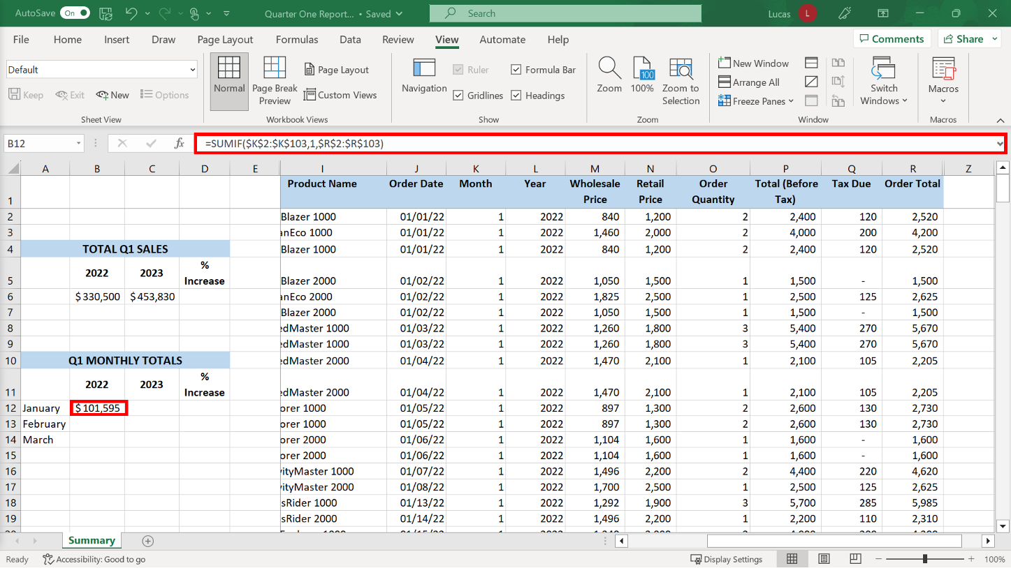

1. You copied the formulas from cell **B12** into cells **B13** and **B14**. In the **B13** copy you changed the criteria to **2** and in the **B14** copy changed the criteria to **3.** The formula in **B13** should read: **=SUMIF($K$2:$K$103,2,$R$2:$R$103)** The result should read $113,445. The formula in **B14** should read: **=SUMIF($K$2:$K$103,3,$R$2:$R$103)** The result should be $115,460.

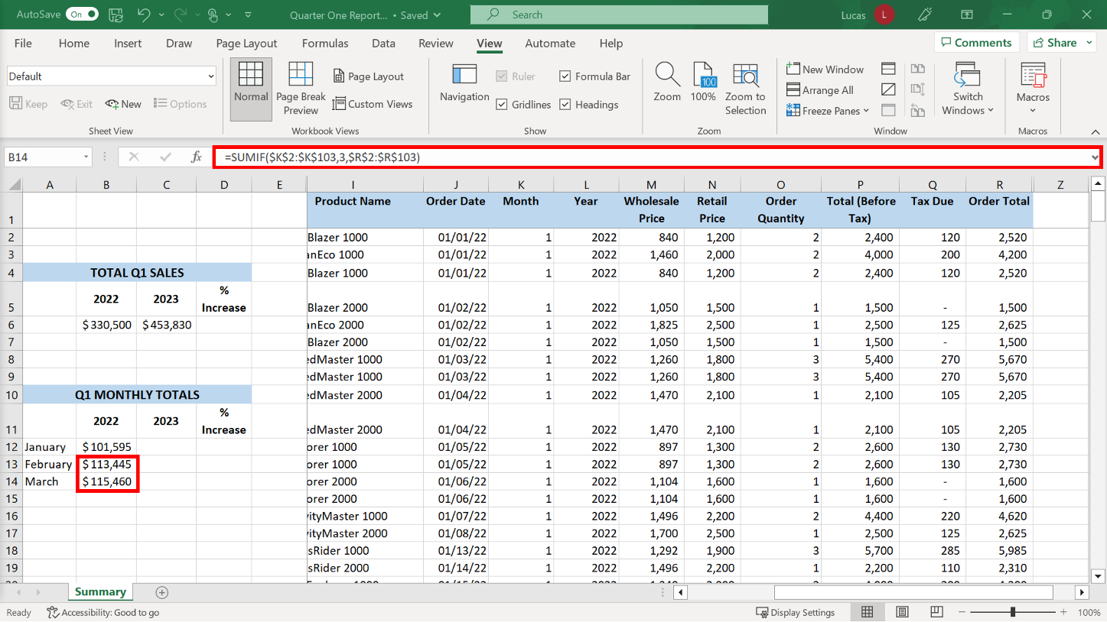

1. In cell **C12** you created a formula using **SUMIF**. This formula summed the range **R104** to **R246** if it said **1** in the range **K104** to **K246**. You added dollar signs to the **R** and **K** cell references. Rows 104 to 246 contained the entries for 2023 because the data had been sorted in date order. To obtain a total for the January 2023 entries, the **SUMIF** formula used a criteria range of **K104** to **K246**, the cells holding the month numbers, and a sum range of **R104** to **R246**.  Matching criteria 1 meant that Excel would only include entries for January in the total. The dollar signs added to the criteria range and sum range cell references allowed for the formula to be copied down.  The formula in **C12** should read: **=SUMIF($K$104:$K$246,1,$R$104:$R$246)** The result should be $143,555.

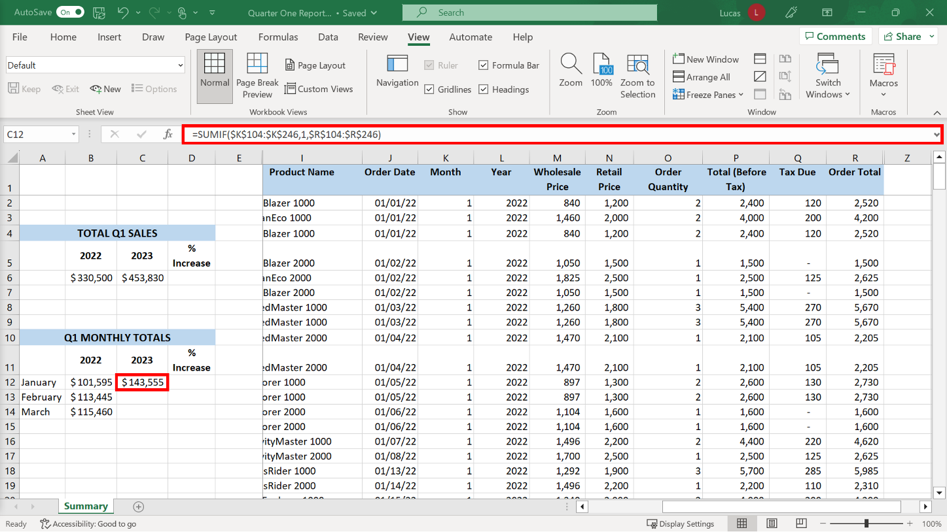

1. You then copied the formula to **C13** and **C14**. In the **C13** copy, you changed the criteria to **2**, and in the **C14** copy, you changed the criteria to **3**. The formula in **C13** should read: **=SUMIF($K$104:$K$246,2,$R$104:$R$246)** The result should be $145,535. The formula in **C14** should read: **=SUMIF($K$104:$K$246,3,$R$104:$R$246)** The result should be $164,740.

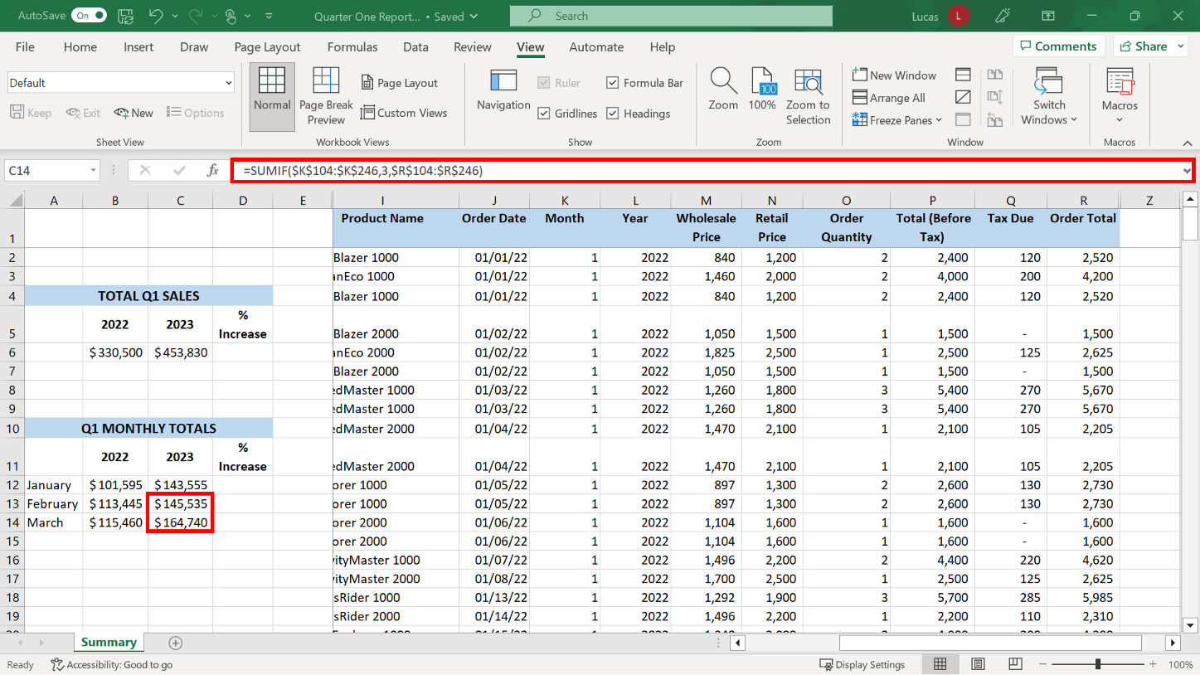

1. You created a **Percentage difference** formula in **D6** which showed the percentage by which sales increased in 2023. To determine the percentage difference between the results for 2022 and 2023, the total for 2022 first had to be subtracted from the 2023 total. The result had then to be divided by the result for 2022. This formula needed parentheses since the subtraction had to be done first. The cell was already formatted as a percentage, so the result displayed correctly. The formula in **D6** should read: **=(C6-B6)/B6** The result is 37.32%.

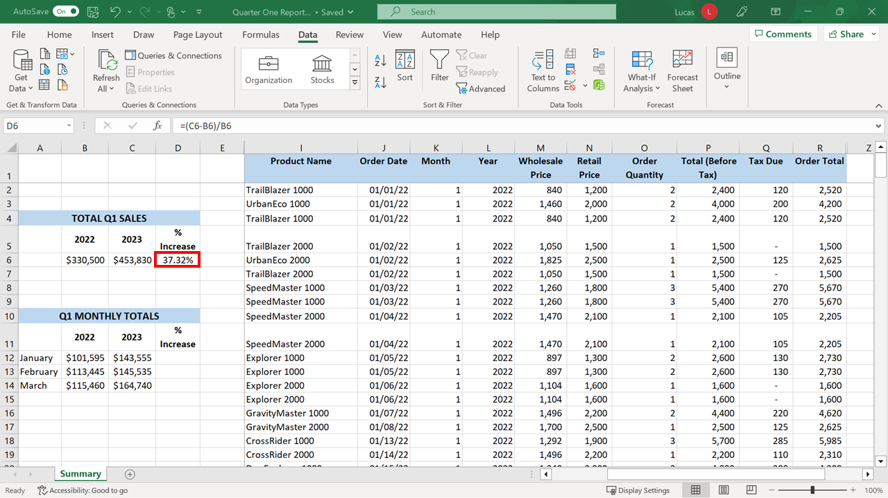

1. You created a similar formula in **D12** and copied the calculation in **D12** down to **D14**. The formula in **D12** should read: **=(C12-B12)/B12** The result should be 41.30%. The formula in **D13** should read: **=(C13-B13)/B13** The result should be 28.29%. The formula in **D14** should read: **=(C14-B14)/B14** The result should be 42.68%.

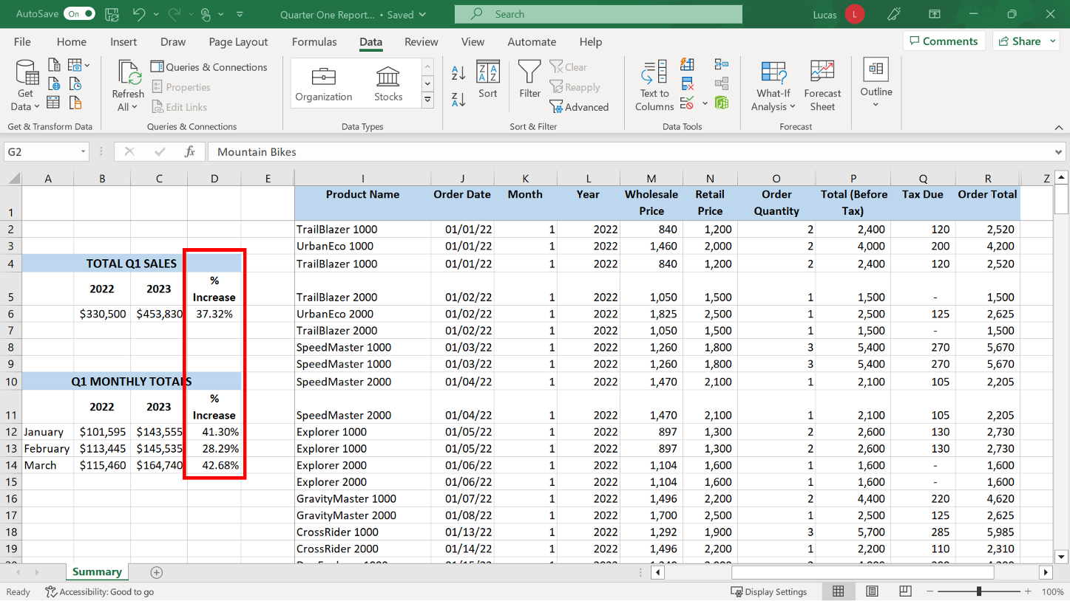

**Conclusion**

In this exercise, you were tasked with using a variety of formatting skills and with creating a range of formulas to create data columns in a spreadsheet and calculate customized totals.

You transformed the standard sales data into a data summary that could be used to inform and drive business decisions. Well done!